CIRCLE LINE
CONTRACT C830
integrated supervisory
control system (ISCS)

ORACLE PASSWORD ADMINISTRATOR user MANUAL

AMENDMENT RECORDS

Rev | Date | Descriptions |  | Writer | Function
- | 15 May 2014 | 1st submission | Status  AC | Gong Liwei | Software Engineer

Reviewed by | Luo BiHui | Approval by | Luo BiHui
Entity / Function | C830 Password Encryption | Entity / Function | C830 Password Encryption
Date & Sign. | 20/05/2014 | Date & Sign. | 20/05/2014
Reserved to the Engineer

Table of Contents

1 Abbreviation 4
2 Reference 4
2.1 Contract Documents 4
2.2 Reference Documents 4
2.3 Standard Documents 4
3 DOCUMENT SCOPE 4
4 Prepare and backup data 5
4.1 Environment check 5
4.2 Stop server 5
4.3 deploy release files 5
4.4 Apply database patch 5
4.5 backup database table 5
5 OPen oracle password administrator 6
6 LOGIN oracle password administrator 7
7 generate and export sql statements 8
7.1 generate SQL statements 8
7.2 Acronyms, and Abbreviations 9
8 Perform update encrypted password 10
9 Revert password If needed 11
10 Verify Password 12
Appendix A – Database Table Backup && Rollback 13
Appendix b – Error Handling 14
Appendix C – Run SQL Statement on Toad for Oracle 15

Abbreviation
C830 | Contract for ISCS
CCL | Circle Line
ISCS | Integrated Supervisory Control System
MFT | Multi-Function Terminal
OCC | Operation Control Centre

Reference

Contract Documents

Reference Documents

Standard Documents

DOCUMENT SCOPE
The aim of this document is to show how to use the toolkit to update operator’s password to the encrypted one on OCC MFT. Station operator can use 'fast refresh' to sync the password from Central Database after OCC complete update operation.

Prepare and backup data
This step contains the following actions:

Environment check
Make sure target machine’s environment correct:
- Hardware: OCC MFT Machine
- Operating System: Microsoft Windows XP Professional SP3 /Microsoft Windows 2000 Professional SP4
- Oracle client: ORACLE 9i client.

Stop server
Stop OCC's and one of the station's transactive agent using "watson kill".

deploy release files
Deploy OraclePasswordAdministarator.exe to the target MFT machine, make sure put "libeay32.dll" under C:\transactive\lib folder. Backup related transactive components and then deploy the new version from the release CD disk.

Apply database patch
Apply database patch CL-Operator-TrgUpdate before update operator table at central database TRANSACT. The folder named “CL-Operator-TrgUpdate” under the release CD disk contains the database patch.

backup database table
Backup “operator” table at TRANSACT database according to Appendix A.

OPen oracle password administrator
Open the folder contains OraclePasswordAdministrator.exe:
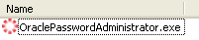
Double click “OraclePasswordAdministrator.exe” to open it:
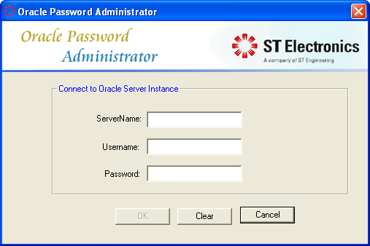
Type in “Server Name”, “Username” and “Password” for Oracle Database instance.
Note that “Server Name” should come from “tnsnames.ora” under Oracle client:
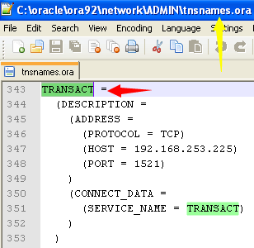

LOGIN oracle password administrator
Click “OK” button after type in all the edit boxes:
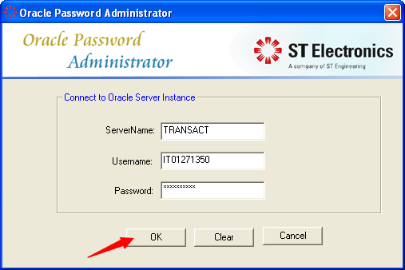
Appendix B.1 show the error handling if type-in incorrect connection information.
After connect to database correctly, the manager will save the connection info, exclude password, to a configuration file, which is under the same folder of the manager, with the name “connectInfo.ini”:
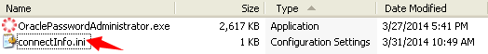
Next time login dialog will use the data from this file, and no need to type-in “ServerName” and “UserName” again if login to the same database server.
The main dialog will pop-up:
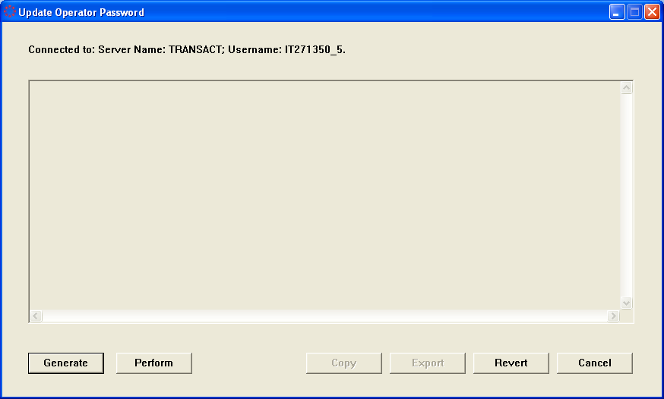

generate and export sql statements

generate SQL statements
This section will generate update and revert SQL statements:
- Update SQL – update current ‘operator’ table’s password to the related encrypted password.
- Revert SQL – revert the password to the one before update action
Only after generate SQL successful, the “Perform” and “Revert” button can be executed, and “Copy” and “Export” button will be enabled:
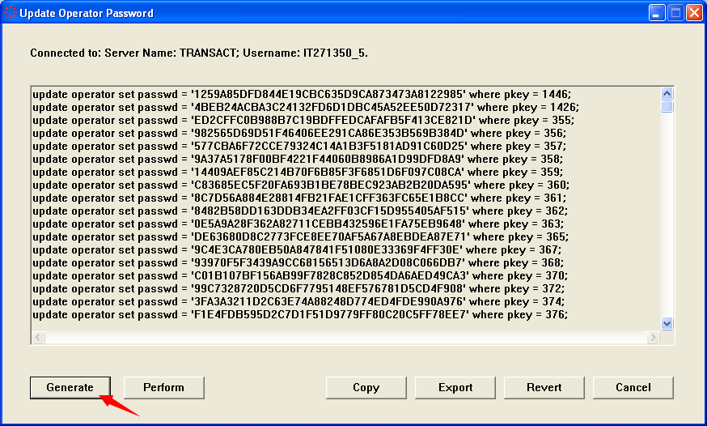
Appendix B.2 show the error handling in this step.
Click “Copy” button will copy the content of SQL statements edit box to clipboard:
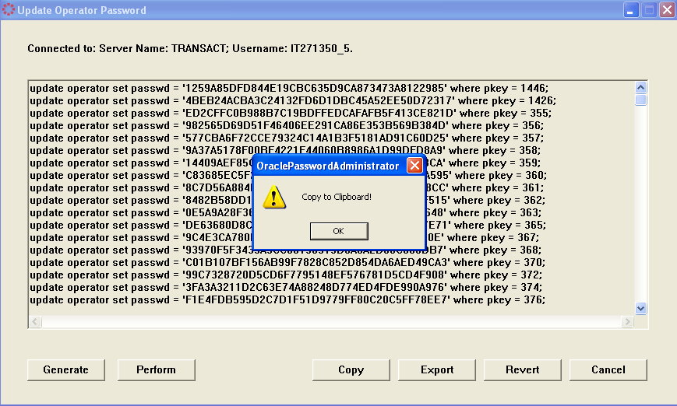

Acronyms, and Abbreviations
Click “Export” will export two “.sql” files, one for update SQL statement, the other for revert SQL statement, the title of the dialog will show its usage:
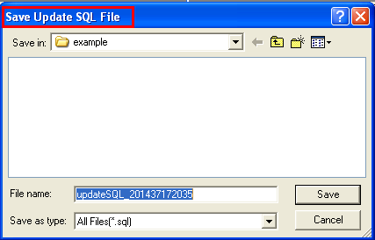
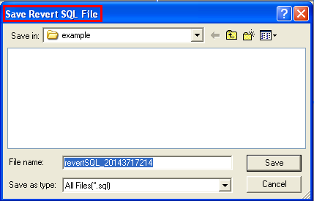
The filename come with current date and time at its end. By default, these files will saved at the same folder as the OraclePasswordAdministrator application.
If needed, run these SQL script files on Oracle Client tools. Appendix C use “Toad for Oracle ” as an example to show how to run the SQL script file.
Station operator can use 'fast refresh' to sync the password from Central Database after OCC complete update operation.

Perform update encrypted password
Make sure already done the “Export” action to export revert SQL file before “Perform” the update statement. If didn’t export SQL files, the manager will pop-up “Save Revert SQL File” dialog when cancel or exit the OraclePasswordAdministrator dialog.
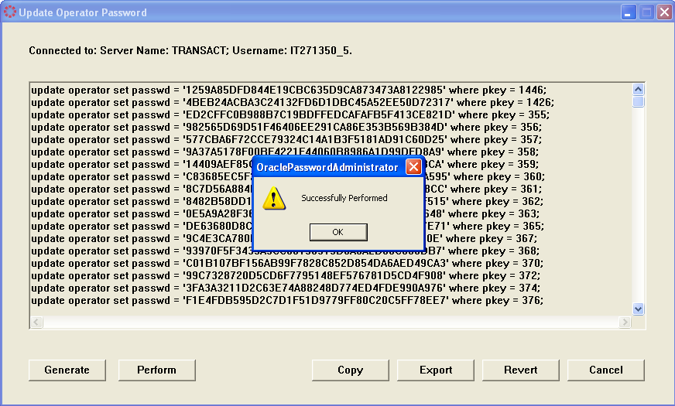
This may take few minutes to finish depends on the operator amount.
Please notice: if have already saved update SQL file, then can run the SQL script on the Oracle client tools, for example, Toad, SQL Plus, etc. Appendix C use “Toad for Oracle ” as an example to show how to run the SQL script file.
If perform the update action correctly, the manager will pop-up a dialog as above.
Appendix B.2 show the error handling in this step.
For station operator password encryption, please use 'fast refresh' to sync the password from Central Database.

Revert password If needed
If want to rollback the password to the previous one, please click the “Revert” button:
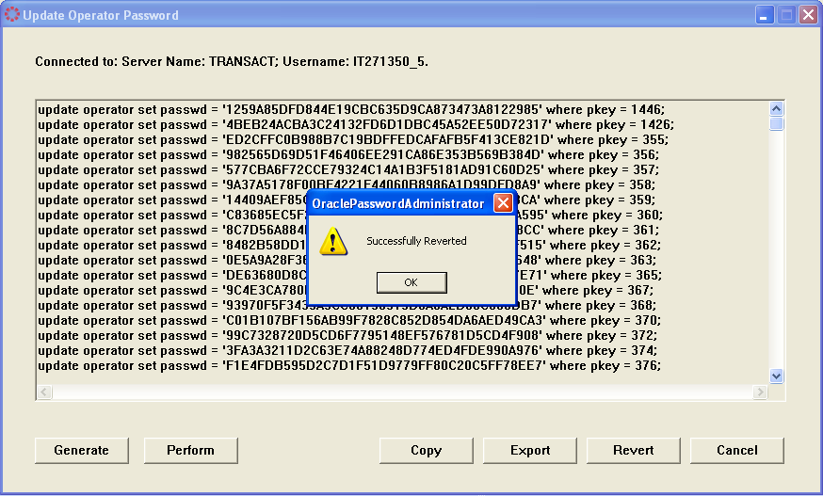
This may take few minutes to finish depends on the operator amount.
Appendix B.2 show the error handling in this step.
For station operator password rollback, please use 'fast refresh' to sync the password from Central Database.
Please notice: If have already saved revert SQL file, then can run the SQL script on the Oracle client tools, for example, Toad, SQL Plus, etc. Appendix C use “Toad for Oracle ” as an example to show how to run the SQL script file. But didn’t save the revert SQL file yet, nor click the “Revert” button before exit the manager, then will be not able to revert the password again. Actually, the revert operation can only perform with "Revert" button before OraclePasswordAdministrator.exe is closed. Else, the password can only be reverted manually with revertSQL_YYYYDDMMhhminss.sql through TOAD or sqlplus.
Finally, if revert password through OraclePasswordAdministrator or revertSQL_YYYYDDMMhhmiss.sql failed, please follow the steps in Appendix A.2 to rollback operator password.

Verify Password
Now can verify the encrypted password through ControlStation or ConfigurationEdtior.
- Start up OCC agents with “transactive start” command, and Station agents with “transactive.station start”.
- Run ControlStation.exe and type in username, profile, location(if local MFT), password in plaintext to login.
- Change password through “Password Modification“ in GraphWorx after login ControlStation successfully.
- Run ConfigurationEditor.exe to add a new operator, then logout ControlStation and login again with the new operator.
- Run ConfigurationEditor.exe to modify operator’s password, then logout ControlStation and login again with the new password of the related operator.
If all these tests passed, use 'fast refresh' to sync the password from central database to the remaining local databases as needed.
If tests failed, need to revert related transactive components and operators’ passwords then revert passwords:
- Stop transactive agents using "watson kill".
- Revert related transactive components at both Agent side and MFT side.
- Revert operators’ passwords according to step 9 “REVERT PASSWORD If needed”.
- Start up OCC and Station agents again and the transactive environment will be revert to the original one.

Appendix A – Database Table Backup && Rollback
Assume that database server name is “TRANSACT”, username is “IT271350_5”, password is “IT271350_5” in this appendix.
- A.1 Backup “Operator” table before running OraclePasswordAdministrator.exe to update password of the table.
# sqlplus IT271350_5/IT271350_5@TRANSACT
sql> drop table operator_bak;
sql> create table operator_bak as select * from operator;
- A.2 Rollback the password of table operator according to below steps if needed.
- A.2.1:
#sqlplus IT271350_5/IT271350_5@TRANSACT
sql> update operator op1 set op1.passwd = nvl((select op2.passwd from operator_bak op2 where op1.pkey=op2.pkey),op1.passwd);
sql> commit;
- A.2.2:
Fast refresh in every Station Databases.
After rollback succeed, all the new operator created or password change at step 10 “VERIFY PASSWORD” will be lost. This means that all the new operator created after Appendix A.1 will be deleted, and the password modified after Appendix A.1 will also reverted to the original one.

Appendix b – Error Handling
Error message will shown in a pop-up dialog when connection login failed or get data failed:
- B.1 Connection login dialog error
If type in wrong, will get the error message box like these:
Incorrect “Server Name”, “Username”, “Password”:
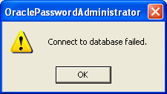
Click “OK” button and the Connection login dialog will be shown again.
- B.2 Get data error
When generating, performing or reverting SQL statement, these dialogs will be pop-up if the network is not working or oracle server is shutdown or get data from database incorrect:
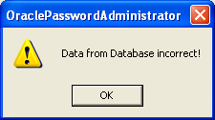
Click “OK” button and please fixed the connection environment or data issue before next operation.

Appendix C – Run SQL Statement on Toad for Oracle
First open “Toad for Oracle” and connect to the Central Database, then click “File” menu and “Open File”:
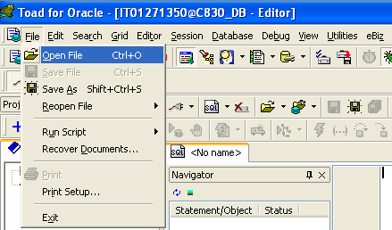
Select the related SQL script file that want to run, for example, “updateSQL_YYYYDDMMhhmiss.sql” is use for update password to the encrypted one, or click “revertSQL_YYYYDDMMhhmiss.sql” to revert password to the original password. Click “Open” button after selection.
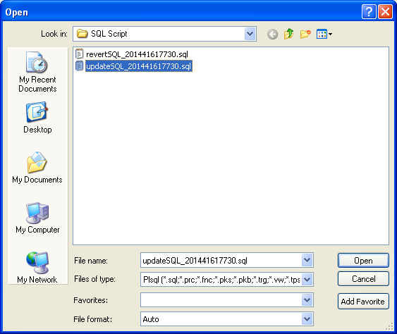
The “Toad for Oracle” will show the SQL script on its SQL editor:
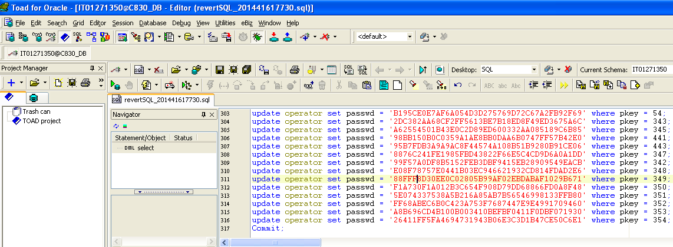
Then selected “Editor” menu and click “Execute as Script” (or just press the button “F5” on the keyboard) to run the whole SQL statements:
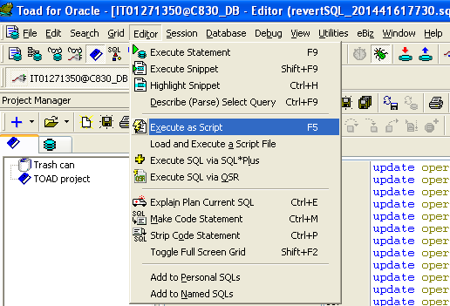
Then the password will be update/revert to the database.

